**New Joint Law Enforcement Center**

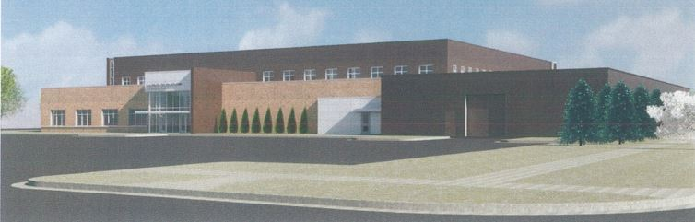

Partnerships

Clay County and the City of Moorhead will work together in the Joint Law Enforcement Center. This facility provides for a one-stop shop for law enforcement needs in Moorhead.

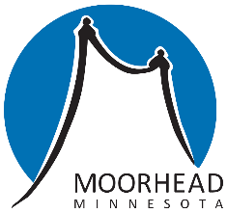

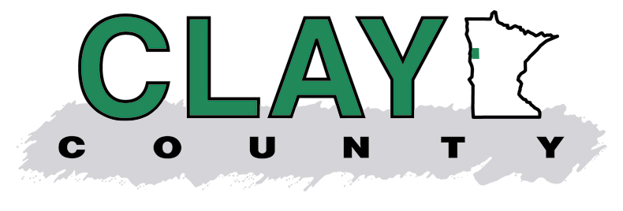

Urgent Issues:

The current Law Enforcement Center is housed in the same deteriorating small building that currently houses the jail. The occupants (Clay County Sheriff’s Office and Moorhead Police Department) lack adequate space, appropriate evidence control, and technical upgrades.

A new Law Enforcement Center will be built immediately north of the Clay County Courthouse. Construction will begin in 2017.

The new Joint Law Enforcement Center will house both the Clay County Sheriff’s Office and the Moorhead Police Department. The building will include administrative space, meeting rooms, investigations, patrol, evidence area, and indoor storage for patrol units. The building is designed for today’s and tomorrow’s threats and security.

The facility will be owned by Clay County. The City of Moorhead will lease space in the Law Enforcement Center.

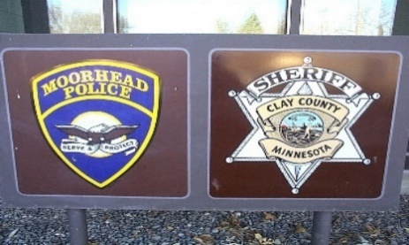

November 8,2016 Ballot:  
**Clay County Question 1**

Yes

No

BY VOTING "YES" ON THIS BALLOT QUESTION, YOU ARE VOTING FOR A COUNTY SALES AND USE TAX

Shall Clay County be authorized to impose a sales and use tax of 1/2% for 20 years or until the project is paid for, whichever comes first, for the purpose of funding a Correctional Facility and Law Enforcement Center?

**County Sales tax for Correctional Facility and Law Enforcement Center**

Financing:

* The total project cost for the Law Enforcement Center and the Correctional Facility will be $52 million. Bonds will be sold to pay for construction.
* The bonds will be repaid by:
  + - Maturing debt
    - Wind energy
  + $50,000 from the levy added each year since 2014
  + Lease payments from Moorhead for space in Law Enforcement Center
    - Sales Tax: (Voted on in November)
      * ½ Cent for 20 years
      * Will generate $1,600,000 per year
    - Or, if the Sales Tax vote fails,
      * Increase in Property Tax

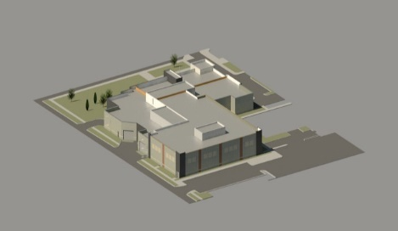



Facilities:  
Located in Moorhead, Clay County operates a jail, detox center, and juvenile detention center.

The existing jail and Law Enforcement Center are inadequate and need to be replaced.

A ½ cent sales tax is proposed to help pay for the new facilities. Without a sales tax, property taxes may increase.

For more information, go to our web site:

claycountymn.gov

Needs:

Currently, the Clay County Jail is non-compliant with State Standards, ineffective for rehabilitation, outdated, too small, has deteriorating infrastructure and needs to be replaced. It is the oldest jail in the state.

Presently, the jail is over capacity, and more than 40 inmates are housed in other jails every day. The transportation costs are significant and availability of beds is limited. 30% of the jail’s inmates are North Dakota residents.

Solution:

Clay County is building a new Correctional Facility which will address the housing needs of its inmates, provide a deterrent to crime, begin a protocol of rehabilitation for violators, and create a safe environment for clientele and staff.

The new Correctional Facility will have a capacity of 208 inmates. It will contain a specially designed Behavioral Health Unit. The new facility will have segregated day rooms for different classes of violators, counseling rooms, meeting rooms, food and laundry facilities.

To take advantage of existing infrastructure and related services, the new Correctional Facility will be constructed immediately south of the current jail on the Clay County campus. Construction will begin in the spring of 2017 and be completed in the fall of 2018.

**New Correctional Facility**